* **SOME SPECIAL TYPES OF MATRIX :**

* **Equal Matrix :**
  + Two matrices A = [aij] and B = [bij] having the same order

m × n are equal if aij = bij for each i = 1, 2, . . . , m and j = 1, 2, . . . , n.

* + In other words, two matrices are said to be equal if they have the same order and their corresponding entries are equal.
* **Row Matrix and Column Matrix:**
  + A matrix consisting of a single row is called a row matrix or a row vector, whereas a matrix having single column is called a column matrix or a column vector.
* **Null or Zero Matrix:**
  + A matrix in which each element is “0” is called a Null or Zero matrix. Zero matrices are generally denoted by the symbol O. This distinguishes zero matrix from the real number 0.

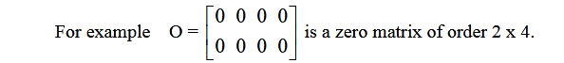

* + The matrix Omxn has the property that for every matrix Amxn, A + O = O + A = A
* **Square matrix:**
  + A matrix A having same numbers of rows and columns is called a square matrix. A matrix A of order m x n can be written as Amxn. If m = n, then the matrix is said to be a square matrix. A square matrix of order n x n, is simply written as An.

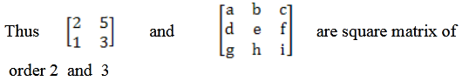

* **Main or Principal (leading) Diagonal:**
  + - * The principal diagonal of a square matrix is the ordered set of elements aij, where i = j, extending from the upper left-hand corner to the lower right-hand corner of the matrix. Thus, the principal diagonal contains elements a11, a22, a33 etc.
      * For example, the principal diagonal of

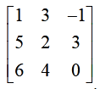

* + - * consists of elements 1, 2 and 0, in that order.
* **Diagonal matrix:**
  + A square matrix in which all elements are zero except those in the main or principal diagonal is called a diagonal matrix. Some elements of the principal diagonal may be zero but not all.

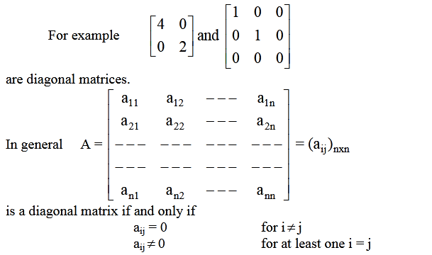

* **Scalar matrix:**
  + A diagonal matrix in which all the diagonal elements are same, is called a scalar matrix i.e.

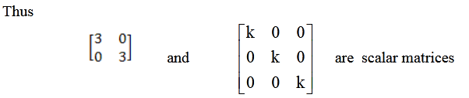’

* **Identity or Unit matrix:**
  + A scalar matrix in which each diagonal element is 1(unity) is called a unit matrix. An identity matrix of order n is denoted by In.

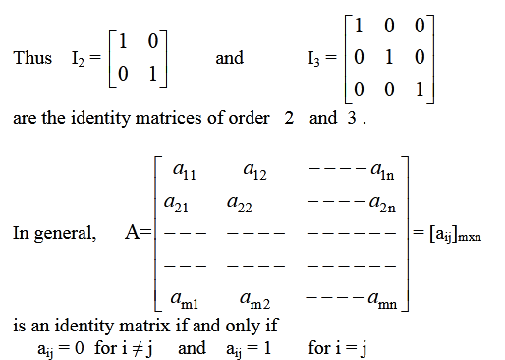

* + Note: If a matrix A and identity matrix I are comfortable for multiplication, then I has the property that AI = IA = A i.e., I is the identity matrix for multiplication.
* **Triangular (Lower** / **Upper) matrix:**
  + Triangular matrices: A square matrix with elements sij = 0 for j < i is termed upper triangular matrix. In other words, a square matrix is upper triangular if all its entries below the main diagonal are zero.
  + Example of a 2 × 2 upper triangular matrix:  
    https://www.web-formulas.com/displayImage.aspx?imageid=559
  + A square matrix with elements sij = 0 for j > i is termed lower triangular matrix. In other words, a square matrix is lower triangular if all its entries above the main diagonal are zero.
  + Diagonal matrices are both upper and lower triangular since they have zeroes above and below the main diagonal.
  + The inverse of a lower triangular matrix is also lower triangular.
  + The product of two or more lower triangular matrices is also lower triangular.
  + The transpose of a lower triangular matrix is upper triangular.
  + The inverse of an upper triangular matrix is also upper triangular.
  + The product of two or more upper triangular matrices is also upper triangular.
  + The transpose of an upper triangular matrix is lower triangular.